Moses as a Leader
Draw three pictures of Moses being a good leader.

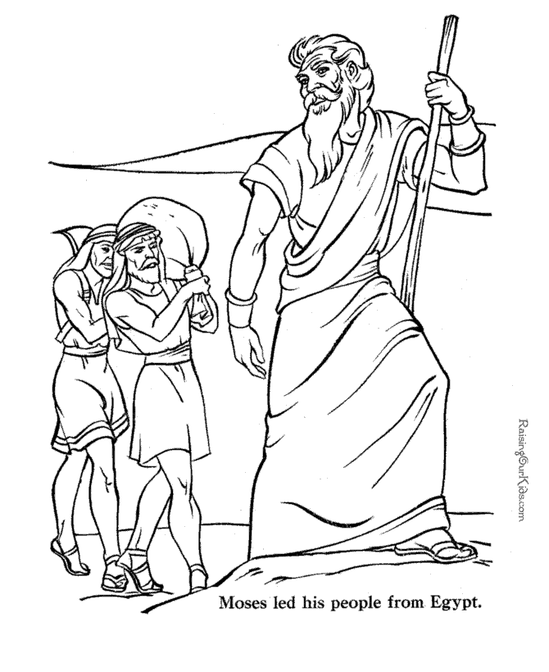
I think Moses was a good leader because_______________________________
____________________________________________________________________________________________________________________________________________________________________________________________________________

