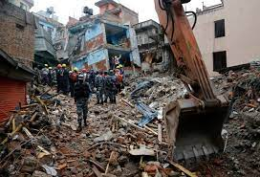
Earthquake Response Unit
In the next few English lessons we will be imagining that we are part of a team of aid workers who have arrived at the site on an earthquake to offer support and help to those who have suffered the effects of the enormous tremor. 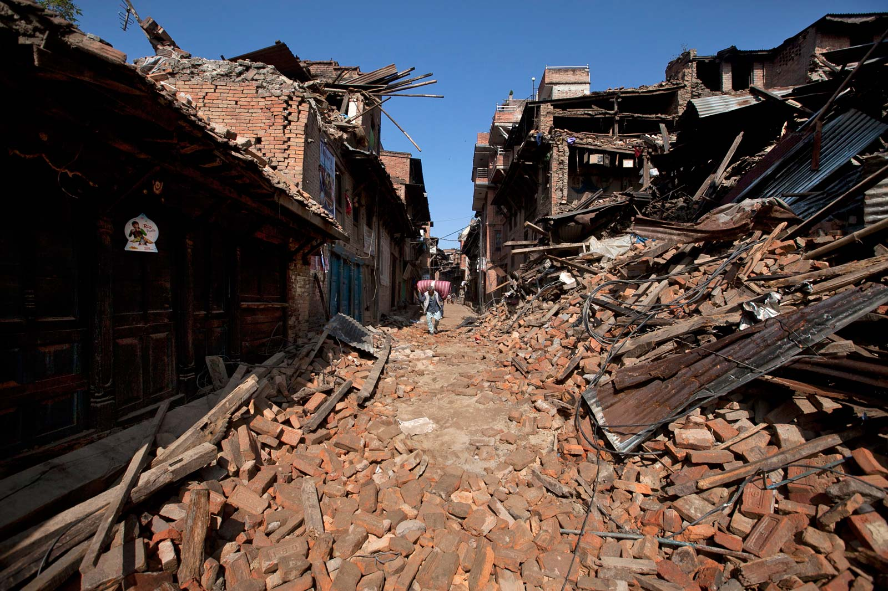
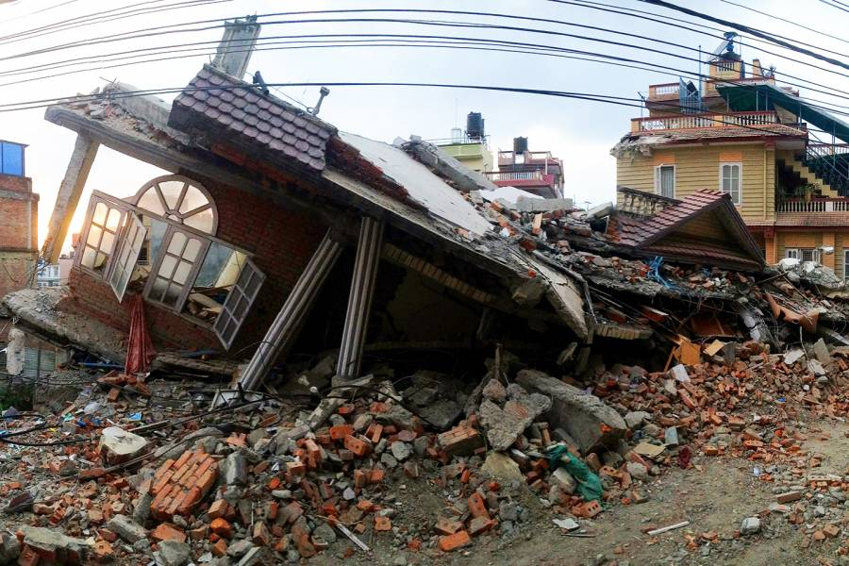
As you step foot off the helicopter you are greeted with sights like the pictures above.
Your first task is to write a short description of the destruction, describing the sights, sounds, and emotions as you survey the scene.
___________________________________
___________________________________
___________________________________
___________________________________
___________________________________
___________________________________
___________________________________
___________________________________
___________________________________
___________________________________
___________________________________
___________________________________
___________________________________
___________________________________

