Toy Day!
Sort Out
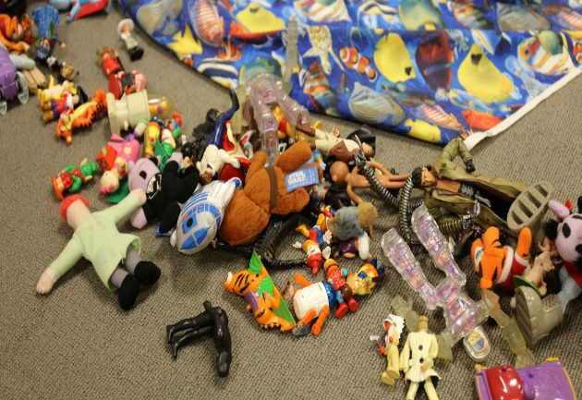
A really fun thing to do before Christmas is to go through your toys and work out the things you play with most and the things you don’t use so much. Then you can decide whether to donate some things to charity, recycle them, throw things away or just keep everything!
Use the template below to help you decide how much you care about each of your toys.
Name of toy | How much do I use it? |  |  | Keep or get rid of it?
 | All the time! | Not that much | Almost never
 | All the time! | Not that much | Almost never
 | All the time! | Not that much | Almost never
 | All the time! | Not that much | Almost never
 | All the time! | Not that much | Almost never
 | All the time! | Not that much | Almost never
 | All the time! | Not that much | Almost never
Now that you’ve sorted your toys into different groups, see if there’s anything you don’t use anymore that you can donate to charity – something you donate could become another child’s favourite present this year!
Finally, spend some quality time playing with your favourite things!

