John Lewis Christmas 2020 Advert – KS2 Comprehension - https://www.youtube.com/watch?v=LUmPzwLNiMk
- Choose one word to describe how the boy is feeling at the start of this advert? Explain your choice. (2 marks)
Word: ________________________________
Explanation:
________________________________________________________________________________________
________________________________________________________________________________________
- How does the girl help the boy to retrieve his ball? (1 mark)
________________________________________________________________________________________
- The snowman gave some of himself to fix the car wheel. Can you think of a synonym and antonym for the word ‘gave’? (2 marks)
Synonym: ________________________________
Antonym: ________________________________
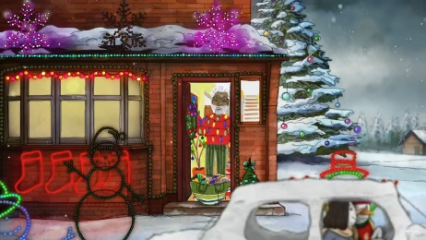
- How does this image capture well the events of 2020? (2 marks)
___________________________________________________________
___________________________________________________________
___________________________________________________________
___________________________________________________________
___________________________________________________________
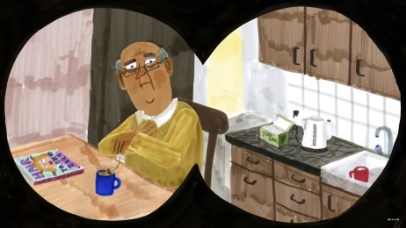
- How do you think this character feels? Support your answer with evidence from the clip. (2 marks)
___________________________________________________________
___________________________________________________________
___________________________________________________________
___________________________________________________________
- The man finds the cracker joke hilarious. Which of these definitions most closely fits with the word hilarious? (1 mark)
- Not funny
- A bit annoying
- Very funny
- Quite boring
- Why do you think the youngest brother has the job of putting the heart on top of the tree? (1 mark)
________________________________________________________________________________________
________________________________________________________________________________________
- ‘The hedgehog wants to be part of the pigeon group.’ What evidence is there to support this claim?(2 marks)
________________________________________________________________________________________
________________________________________________________________________________________
- How does the lady on the bus help to fix the girl’s glasses? (1 mark)
________________________________________________________________________________________
- Why do you think the decision was made to start and end this advert with the boy and girl? (2 marks)
________________________________________________________________________________________
________________________________________________________________________________________
- Order these events from 1 – 5. One has been done for you. (1 mark)
- A woman on a bus helps to fix a girl’s glasses. _
- Two men in different houses pull a cracker together. _
- A boy’s ball is stuck up a tree. 1
- Four pigeons fly an aeroplane. _
- A snowman helps to fix a car tyre. _
- Summarise what you think the key message of this advert is. (3 marks)
________________________________________________________________________________________
________________________________________________________________________________________
________________________________________________________________________________________________________________________________________________________________________________

